LYNFIELD COLLEGE
2026 STUDENT ASSESSMENT COVER SHEET
Course Title: 3PAD
Students Name: _Janidu Hettiarachchi_
Due Date: 7th August 2026

Subject Reference |  | Digital Technologies and Hangarau Matihiko 3.8
Number |  | AS91907 Version 2
Title |  | Use complex processes to develop a digital technologies outcome
Level | 3 | Credits | 6 | Assessment | Internal
This achievement standard involves using complex processes to develop a digital

Achievement Criteria:

Achieved | Merit | Excellence
Use complex processes to develop a digital technologies outcome. | Use complex processes to develop an informed digital technologies outcome. | Use complex processes to develop a refined digital technologies outcome.

Authenticity statement:

The work that I have submitted for this assessment is my own.
I understand any material used and/or quoted that is not my own must be acknowledged in the appropriate manner. I understand that the use of chatbots, generative AI, paraphrasing tools, or other tools that can automatically generate content is not permitted. Material generated by these tools has not been included in this submission.
I understand any material used and/or quoted that is not my own must be acknowledged in the appropriate manner.
I have acknowledged all direct quotes and references used in this assessment.
I understand that plagiarism and/or collusion with other students may result in disciplinary action and a Not Achieved grade being given.
If submitting a digital copy of this assessment I agree to the above.

Student Name…Janidu Hettiarachchi………

Student Signature ......Janidu Hettiarachchi................... Date.......................

Grade awarded:

Not Achieved | Achieved
Merit | Excellence

TEACHER’S SIGNATURE ..........................................................
Context/Te Horopaki
This is an integrated assessment activity supporting a project approach that assesses against two achievement standards which are AS91907 and AS91906.
This activity requires students to plan and manage the development of a computer program using complex programming techniques.
Using complex processes will support the development of a refined computer program that has been comprehensively tested and debugged. You should be supported to synthesise information gained from the planning, testing, and trialling of components to develop a high-quality outcome. Both achievement standards require testing to improve the quality and functionality of the outcome.
You need to discuss how the synthesis of the information gained assisted in the development of a high-quality outcome.
Students will use Python programming and tkinter, as it supports a range of complex programming techniques.
Conditions/Ngā Tikanga
You will have at least two identified checkpoints that held by the teacher as you work through this assessment activity to ensure you have an opportunity to ask questions and gather feedback.
The format of the final outcome is a computer program.
You will need to supply evidence of using recognised and appropriate project management tools and techniques to plan and manage the development of your computer program. This will include trialling and testing the components of the program (see student task for more details).

You are assessed on planning the development of the outcome.
You are not assessed on planning the outcome itself.

For AS91907 you are required to use:

- recognised and appropriate project management tools and techniques to plan the development of a digital media outcome.

To do this, you need to:

- decompose the digital technologies outcome into smaller components

- trial the components of the outcome

- test that the digital technologies outcome functions as intended

- evaluate the process

In 91906, you are stepped through the process of creating a digital media outcome, and 91907 you are stepped through the process of programming an outcome.

As you create your outcome for this assessment, plan the steps you will follow to create the outcome, trial and test components and then evaluate the process you followed for AS91907.
Planning, Development & Testing Requirements
Your program needs to be developed using complex processes and you will need to show evidence of this process.
- Use recognised project management tools to help you plan and the development of your program.
- Decompose your outcome into components. You should trial multiple components or techniques to determine which one will be best for the overall quality of your outcome. For example, you might trial the use of pop-up menus, text boxes or radio-buttons to get the same information from the user in a GUI. You might assess their quality in terms of functionality, usability, flexibility, interface aesthetic, etc. for your outcome.
- You need to provide evidence of effectively using the information from testing and trialling to improve the functionality of the outcome. You may use your project management tools to record and gather evidence of testing, trialling and feedback. Alternatively, you could take screen captures, recorded in a simple table showing dates, images and a brief statement identifying the stage of your process. You could also capture the process using screencasts. Whatever approach you use, be sure to annotate/discuss the changes you have made and why.
- Provide evidence of comprehensively testing your final outcome.
- Address any relevant implications such as social/cultural, legal/ethical, intellectual property, privacy, accessibility, usability, functionality, aesthetics, sustainability and future proofing, end-user requirements.
- Synthesise the information from the planning, testing and trialling of components to develop a high-quality outcome.
- Discuss how this information led to the development of a high-quality outcome.
- This should include evidence of how the outcome addresses relevant implications.

Planning Tools

The Education Training Module has Project Management tools for drafting up a plan. They are Gantt Chart, Project Timeline, and Project Tracking. Complete your own research to find a tool that suits you.

Gantt Chart – this is a bar chart that tells a visual story. It is like a visual to-do list. Filling in cells with different colours, using clear labels and headings and breaking down tasks into small chunks helps to determine a robust workflow.

Project Timeline – this is similar in looks to a Gantt Chart. It has clear stages.

Project Scheduling – this tool is less visual. It works with task descriptions, start and end dates.

Resources

Project Management Tools and Techniques:

A project has a beginning and an end with lots of steps (tasks, processes) that are completed at various points along the project timeline. In this context, project management tools and techniques are used to document the process of outcome development. Project Management involves planning the steps to take and documenting them as they are taken. Progress is tracked and end users are consulted.

It is important that you do your own research to find a project management tool that suits your workflow. From the standard, examples of project management tools and techniques include:

• Agile or waterfall techniques

• Kanban

• Version control

• Collaboration and Communication

• Code review

• Project scheduling

NOTE 1: It is not a requirement that you utilise all of these techniques and tools. It is up to you what you use. However, you must use at least two tools to manage your project.

NOTE 2: Check the usability of your Project Management Tool. Some tools offer you 30 days free; others restrict the number of cards/boards you can use.

Techniques:

These are software development methodologies.

Agile – continuous iteration. Changes allowed in the project.

Waterfall – sequential order. The project only moves forward if the previous step or phase is complete. Simplest technique for small projects.
https://www.youtube.com/watch?v=egF9-FejbsA

Tools:

Kanban– Kanban is a visual process and project management tool. Read more here and complete your own research more on Kanban found here: https://www.atlassian.com/agile/kanban/boards

Version Control – saving each iteration as the outcome is developed allows the designer to revisit an earlier version at any time. https://library.stanford.edu/research/data-management-services/data-best-practices/data-versioning

Collaboration Tools - examples include Trello, Padlet, Figma, Slack, Asana, Microsoft
Teams, Microsoft Tasks, Microsoft ToDo, Fleep, Monday.com. These can be used to showcase your development for feedback from end users. Google Forms can be used to gather feedback, or a questionnaire created in other software such as Microsoft Word. Choosing the right collaborative tool is important for sharing your development with end users and collecting feedback. Slack, for example, can be integrated with Google Forms.
Google Forms are one way of questioning end users. Responses are automatically collated in a Google Sheet.

Managing Assets – examples include folder management, version control, managing images, naming files correctly

Code Review - Examples include using the WOF Python 3 style checker, assert method, rubric style evaluation of correctness, efficiency and reliability

Project scheduling - to break tasks into smaller steps, set deadlines, and track progress, e.g. Gannt Chart for project milestones and then To-Do lists for each milestone

Trial and Test

- For each component, trial and test with end users
- Repeat the cycles of trialling (gather information) and testing (make decisions) until you are satisfied that you have iterated enough to have a high-quality outcome.

Reflection

Create a document and save it as ‘Reflection’. Set up headings and discuss the questions as outlined below.
- How has the combination of planning, utilising project management tools, collaboration tools, and feedback tools helped you to create a high-quality outcome?
- How has the information you have gathered from the planning, trialling and testing of components lead to the creation of your final outcome?
- How have you addressed your relevant implications in your final outcome?

Assessment schedule/Mahere Aromatawai: Digital Technologies/Hangarau Matihiko 91907 – Use complex processes to develop a digital technologies outcome
Evidence/Judgements for Achievement/Paetae | Evidence/Judgements for Achievement with Merit/Kaiaka | Evidence/Judgements for Achievement with Excellence/Kairangi
Use complex processes to develop a digital technologies outcome.  The student has:  - Created three different concept designs and chosen one based on feedback  - Used two recognised and appropriate project management tools and techniques to plan and manage the development of a digital technologies’ outcome (Note: one needs to show clear development over a timeline).  - Trello Board (Kanban)  - Gantt Chart (Waterfall)  - Other………………….  - Decomposed the digital technologies outcome into smaller components using two Decomposition Tools:  - Decomposition Table  - Flow Chart  - Mind Map  - Other……………….  Collaboration Tool used(any two):  - Google Docs  - Google Forms  - Interviews (with interview logs)  - Emails  - Survey Monkey  - Version Control (Git Hub Link shared)  Trailed components of the outcome:  - ___________  - ___________  - ___________  - ___________  Evaluation Tool used: (Any one)  - Plan of Action  - Client Consultation Logs  - Key Stage Plan  For example (partial evidence):  The student has used appropriate project management tools and techniques, such as Agile with a Trello or Kanban board, to plan and manage the development of their outcome. The outcome has been broken down into smaller components and these have been trailed and tested. The components have then been combined into a working outcome.  - Tested that the digital technologies outcome functions as intended.  For example (partial evidence):  The student has provided evidence of testing the outcome to ensure that it functions as intended: The testing might be missing some of the desired detail and the program might not work as intended for unexpected data but works for intended input.  Relevant Implications:  - Addressed 5 relevant implications.  For example (partial evidence):  The student outcome is easy to use, fully functional, aesthetically pleasing and honours copyright legal obligations.  The examples above are indicative samples only | Use complex processes to develop an informed digital technologies outcome.  The student has:  - Effectively used project management tools and techniques to manage development, feedback and/or collaborative processes  Collaboration Tools:  - The student provides evidence of sharing documents/data and managing feedback. For example, they used Google Team Drive to share design ideas and to seek feedback.  Planning Tools and trialling:  - The student provides evidence of how they managed their work-flow. This could include screen captures of a Trello board or any other valid planning tool.  - Effectively trialled multiple components and/or techniques then selected the best one based on usability.  For example (partial evidence):  Evidence can be seen in their project management tool(s) and/or logs that includes notes of the component(s) and/or techniques trailed with notes regarding the outcome or next steps.  - Effectively used information from testing and trialing to improve the functionality of the digital technologies’ outcome.  For example (partial evidence):  The student provides evidence of testing and trialing during development and they have indicated how they improved their outcome using this approach. Evidence can be seen in their project management tools and/or logs that includes annotations of changes made to improve the functionality.  Version Control:  - The student has managed their versions effectively through the use of structured file and folder naming conventions and back-ups.  - The student provides evidence of versioning the outcome where new versions either have improved functionality or added features.  The examples above are indicative samples only  Relevant Implications:  - Explained implications in detail and linked them to the project context. | Use complex processes to develop a refined digital technologies outcome.  The student has:  - Combined information from the planning, testing, and trialling of components.  - Referred to and provided a comprehensive analysis of multiple relevant implications throughout the project.  For example (partial evidence):  The student outcome is of high quality as a result of students effectively using project management tools and techniques, to efficiently manage the trailing, testing and refinement process. They have incorporated user suggestions and feedback to improve the usability, aesthetics, and functionality of the outcome.  Evaluation:  The student has:  - Discussed how the process led to the development of a high-quality digital technology’s outcome. How did the tools help in your project development?  For example (partial evidence):  The student has reflected on their use of processes to develop their outcome and provided evidence of how the process helped them to effectively test and trial various components to refine and enhance the design and functionality of their outcome.  The examples above are indicative samples only  Relevant Implications:  - Integrated and critically discussed implications throughout the project.
Comments:

Final grades will be decided using professional judgement based on a holistic examination of the evidence provided against the criteria in the Achievement Standard.

The below questions allow you to follow a structured way of approaching the AS91907. Note that where it says (Add answer here) an answer is required. In order to receive an achieved in this project all questions must be answered at a reasonable level (more than just one sentence).
Planning

Concept design (Sketch/Draft):

Use the below space to add three sketch/draft concepts of your program. Remember to sketch all windows, images, buttons and text. You can use photos of your hand sketch, lucid charts or other illustrative software to complete this.

Concept 1

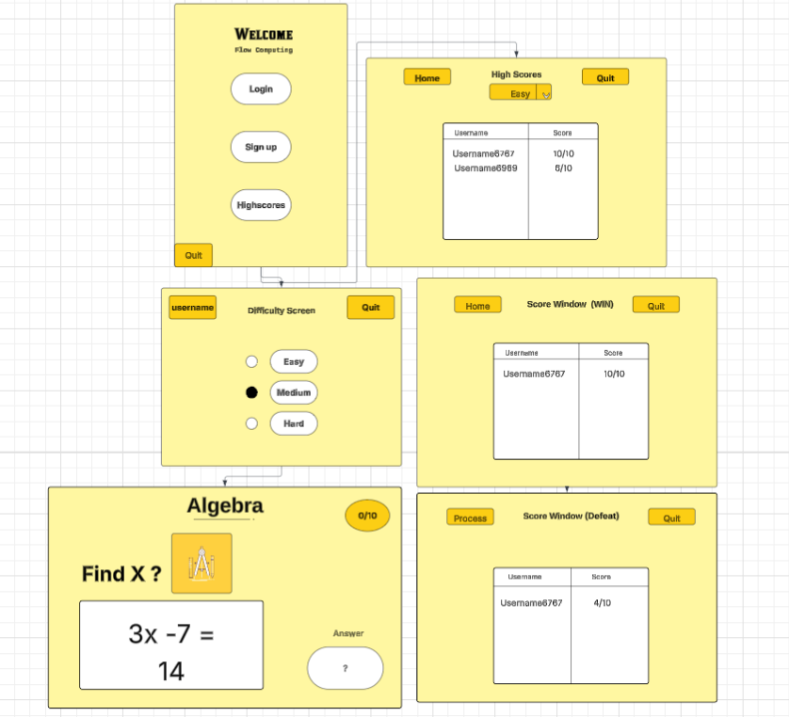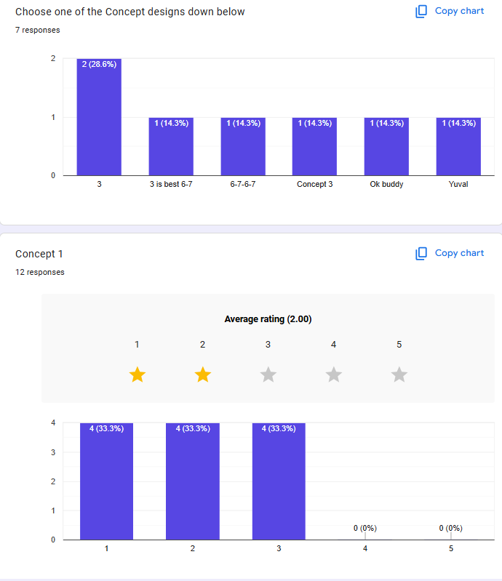
Concept 2
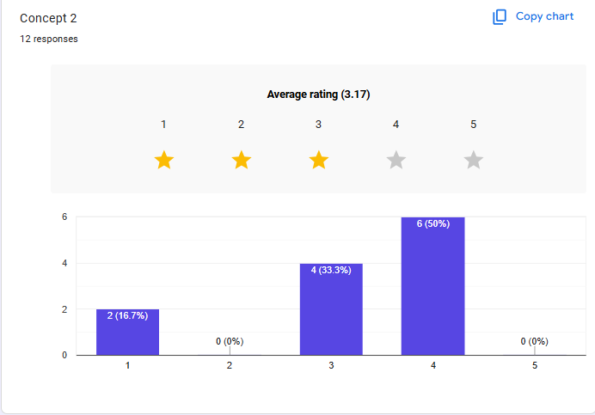
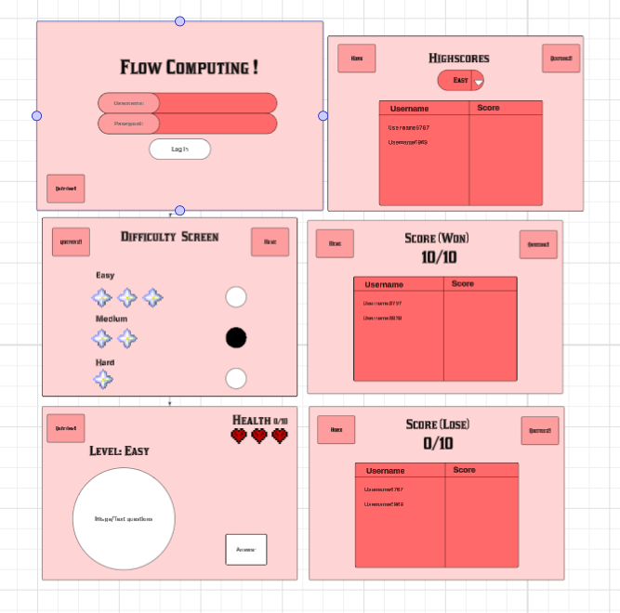
Concept 3
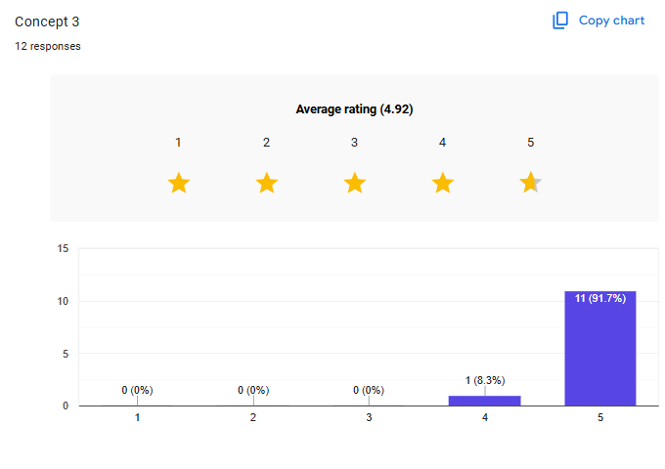
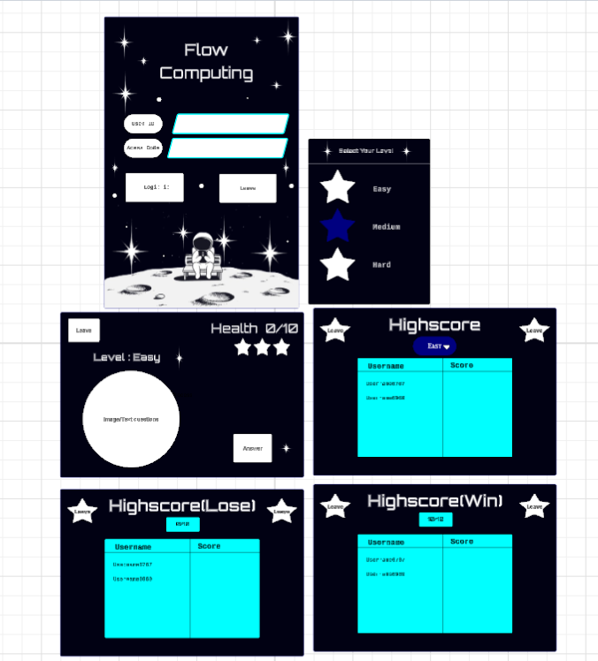
Final Concept

The “Flow computing” space exploration concept was selected because it met and integrated several; of the spacesuit design implications-such as aesthetics, usability and end user equipment’s in a a successful educational method. The high contrast dark mode interface with neon cyan accents might look more modern and engaging form an aesthetic perspective and it might help from the help from the usability standpoint as you don’t end up feeling fatigued due to all bright colours. The immersive and interactive experience theme makes a simple concept of algorithms problem solving into an interesting game, bringing a particular group of users into a facilitated “flow state”, able to do more work with the app.


What is the Purpose of your program?
The purpose of “Flow computing” is to create an interesting, game-based learning resource to help cultivate computational and mathematical thinking or problem solving (algebra) skills in high school student. The program’s goal is to address the issue of a low-rate students’ participation in traditional
and take classrooms and learning around the world through a study “mission” in outer space. It implements a high score leaderboard, a health/ lives system and gradually increased the difficult levels on each tabling (Easy, Medium, Hard) to engage the user innkeeping his attention. The idea at the end of the program is for the user to enter a “flow” state, where there is no thought to distract or “wear down” the eyes, and a user can have a better learning experience, which translates into a better retention of knowledge.

Specifications: What are some things that are essential for your GUI to show? E.g. Score, Wrong Answer, Right Answer, Results.

The GUI must show:
- Current score and questions progress
- Health points (display as heart icons, default 3 lives)
- The Leaderboard= username and high score, the top 10
- Win/Lose outcomes on the screen
- Answer input field and submit button
- Username entry field on the start screen
- Space background image displayed behind the game frame
- Planet/rocket sprite shown alongside each question
- Heart icons for the lives display (instead of plain text)
- Logo/title image on the start screen

Specifications: What are some functions that are required of your program? What sort of inputs should your program ask for and how will you error-proof the inputs? Will error messages show on a separate window?
main()- initialises tinker root window and calls
start_screen()- Display the welcome frame
generate_question()- A function that uses random module to create an algebra question at a random difficulty level
check_answer() — reads in the answer box, checks if the user typed the right answer or not, and adds or subtracts a life and/or score.
validate_input()- proofs the entry field that checks for empty field, numeric field, and no special characters. Display a message box on any failures.
update_display()- refreshes the score board
leaderboard()- reads scores.txt, sorts entries in descending order, and display the top 10 in a treeview widget
save_score()- the current username and score to scores.txt on the game
load_images() — loads and resizes all image assets using the Pillow (PIL) library. Called once at the start of the program before the GUI is built.

Project Management Techniques (Methodologies):

            - Research Project Management Techniques (Methodologies) E.g., Kanban.
Agile – A project management and product development approach that breaks large iterative cycles known as sprints. The work is finished in short cycles (sprints), and the feedback is taken on a continuous basis. This is appropriate for projects that might change the course of development.
Waterfall - a linear process that requires the completion of one phase before the next is started. The order of phases is generally: Planning- Design – Implementation- testing- Development. Best suited for small and clearly defines projects with clear requirements.

            - Choose one and justify your choice.
The chosen Techniques is Agile because of the Flow computing program focusing ongoing trialling and testing out parts of the program with end users. These requirements were shaped through user feedback and Agile’s nature is to embrace such changes. It was also possible to develop, test and improve individual parts (such as the input validation module, the leader board) without affecting the rest of the program, and then add them to the final program.

Project Management Tools:

      - Below add Research on Project management tools e.g. Gannt Chart, Plan of Action, Trello Board, Flow Diagram etc (You can use a PMI chart for to assist you with this task and/or look at the pros and cons):
Gantt Chart: A horizontal bar chart that shows tasks with a timeline: Gantt Chart. Each task is shown as a bar chose length represents the duration of the task. Gantt Chart are helpful to view task overlaps, critical paths and if the project is running on schedule.
Disadvantages: May become very complicated and difficult to keep up on large projects.
Trello board (Kanban): A visual card-based tool which structures takes into columns (To Do, In Progress, Done). Cards can be transferred between columns as work proceeds, due dates set, and cards categorized. Trello is cloud-based and free platform for personal use.
Disadvantages: Does not have a built-in task duration or timeline view.
Plan Of Action: A simple table depicting tasks, deadlines, and responsible parties is known as Plan of Action. Light weights and simple to install, but no timeline visualization and not easily extensible to complicated projects,

      - What are the Two Project Management Tools chosen along with justification (Remember you need at least one that measures timeline):

Tool1: Gantt Chart: It was chosen as the main timeline tool since it is a visual representation of the project schedule. The Gantt chart can be used to map each of the development phases Planning, GUI build, Function development, Testing, Documentation to individual weeks to ensure that deadlines are met and that time-consuming phases are allocated appropriately. The timeline view will also allow you to easily see when milestones are supposed to be completed and of the project is slipping.
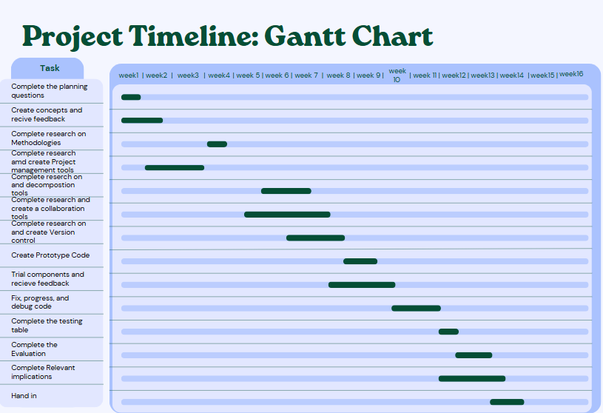
Tool 2: Trello Board (Kanban ): Trello was chosen as the second tool since it helps in tracking tasks at the level of each phase of the project in addition to Gantt chart. Cards were developed for every function, GUI design element and documentation section and navigated through To Do In Progress Testing Done columns, it was simple to spot at a single glance the finished and the blocked components. Trello’s free version was good enough for a 1- developer project and there was no restriction on the number of cards or boards.
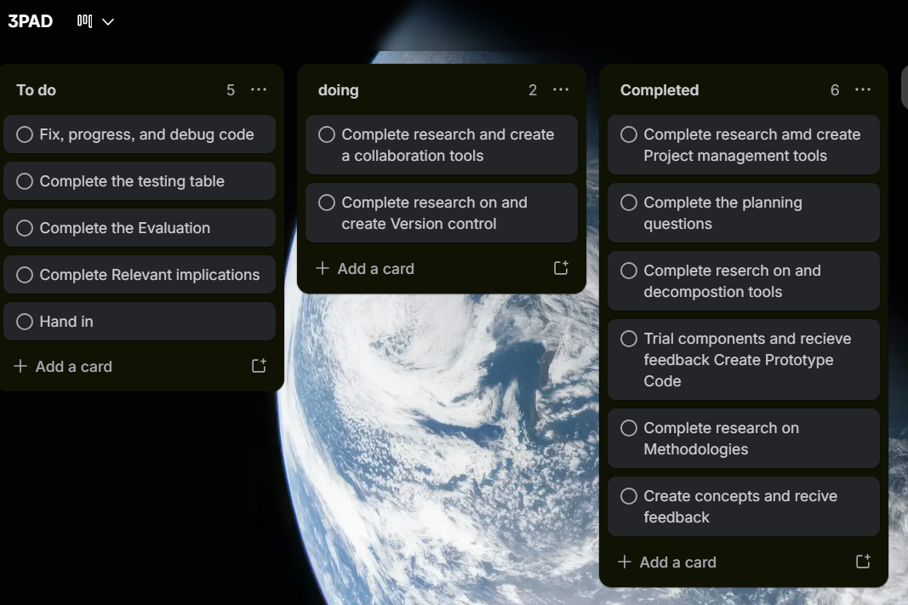

Decomposition Tools:

            - Perform research on decomposition tools and add this below. You could research, To Do Lists, Decomposition Table, and Mind Map etc:

Decomposition Table — a table that is organized to decompose a program into its significant parts, subparts, options tested, and descriptions. It is good for systematically defining all components of the program prior to coding and as a reference while developing the program.
Flowchart — A diagram used to illustrate the logical flow of a program from beginning to end with the use of symbols (terminals, processes, decisions, input/output parallelogram). Flowcharts clearly illustrate the logic of the program and can be used to mark decision points and loops before coding a program.
Mind Map — radial diagram with branches that radiate out from the central concept. It serves as a brainstorming tool and for defining general categories but is not as detailed as a decomposition table or flowchart used for technical program planning.
            - Show two of the Decomposition Tools for completing this brief along with your justification:

Component | Subcomponent | Details / Specs | Description
GUI window  Layout and size | Colour | Dark blue  #0A0A2A | Background colour for the main tkinter window
 | Size | Width = 480px, Height = 680px, non-resizable | Fixed window size set with resizable(False). Width 480px, height 680px ensures consistent layout across screens
 | Frame | Non-resizable | Window frame is locked so the user cannot resize or distort the layout
Fonts Size, style, colours | Size | 11/16/20 px | Font sizes vary by element: 11px for small labels, 16px for standard text, 20px for headings
 | Style | Orbiton / Courier | Orbiton is used for headings to give a sci-fi space theme. Courier is used for question text for readability
 | Colours | Cyan / white | Cyan is used for heading text to contrast against the dark background. White is used for body text. Bold headings applied throughout
Buttons Style and behaviour | Colour | Cyan outline | Buttons use a cyan border outline on a dark background to match the overall colour scheme
 | Shape | Rounded rectangle | Buttons are styled with a rounded rectangle shape using the relief and border width options in tkinter
 | Hover effect | Glow on hover | Buttons change appearance when the cursor hovers over them, providing visual feedback to the user
Label and Display Score, HP, Questions | Score | +10 per correct | Score label updates by +10 each time the user answers correctly. Always displayed on screen
 | Lives / HP | 3 lives default | Player starts with 3 lives. One life is deducted per wrong answer. Lives are shown as heart icons on screen
 | Leaderboard | Top 10 scores | Leaderboard reads from scores.txt and displays the top 10 entries sorted by score descending
 | Question No. |  | The current question number is displayed on screen, so the player knows their progress through the quiz
Core Functions Program logic | start_screen() | Username input, Difficulty select | Displays the start screen. Collects the player's username and chosen difficulty (Easy / Medium / Hard). Validates that username is not empty
 | generate_q() | Random algebra, Easy/Med/Hard | Generates a random algebra question based on the selected difficulty. Uses the random module to produce numbers and operations
 | check_answer() | Score/HP update, Win/lose check | Win/lose check Compares user input to the correct answer. Updates score (+10) or lives (-1) accordingly. Checks if the game is won or lost
 | validate_input() | Numeric check, Empty/special chars | Checks that the user's answer is a valid number. Rejects empty input and non-numeric/special characters with an error message
 | leaderboard() | Read scores.txt, Sort and display top 10 | Opens scores.txt, reads all entries, sorts them by score descending, and displays the top 10 on the leaderboard screen
 | load_images() | PIL open & resize, Store as PhotoImage | Loads all image assets using PIL (Pillow). Resizes them to fit their display locations and converts them to tkinter-compatible Photo Image objects
Data and Files Storage and variables | Variables | score, lives | Key game variables: score (int, starts at 0), lives (int, starts at 3), username (str), q.no (int) — all initialised at game start
 | File I/O | scores.txt, append / read | scores.txt is read at the start of leaderboard() to load existing entries, and written to after each game to save the player's score and username
 | Error handling | try / except, message box | try/except blocks catch file errors and invalid inputs. tkinter message box is used to display user-friendly error popups
GUI Images / Assets | Background image | space_scene.png | A space-themed background image loaded via PIL and displayed behind all widgets on the main game screen
Tool 1: Decomposition table: A decomposition table was used as it systematically and systematically identifies each element of the program in a structured format, showing the options and trials for each element. It is easily understandable by a developer what should be studied, what were the options and what is the goal of each piece. It also helps the trialling process by providing a visibility of all the parts and options before the development.
https://lucid.app/lucidchart/90e38fa8-f9ae-46b6-8a45-d396535eb8c4/edit?vie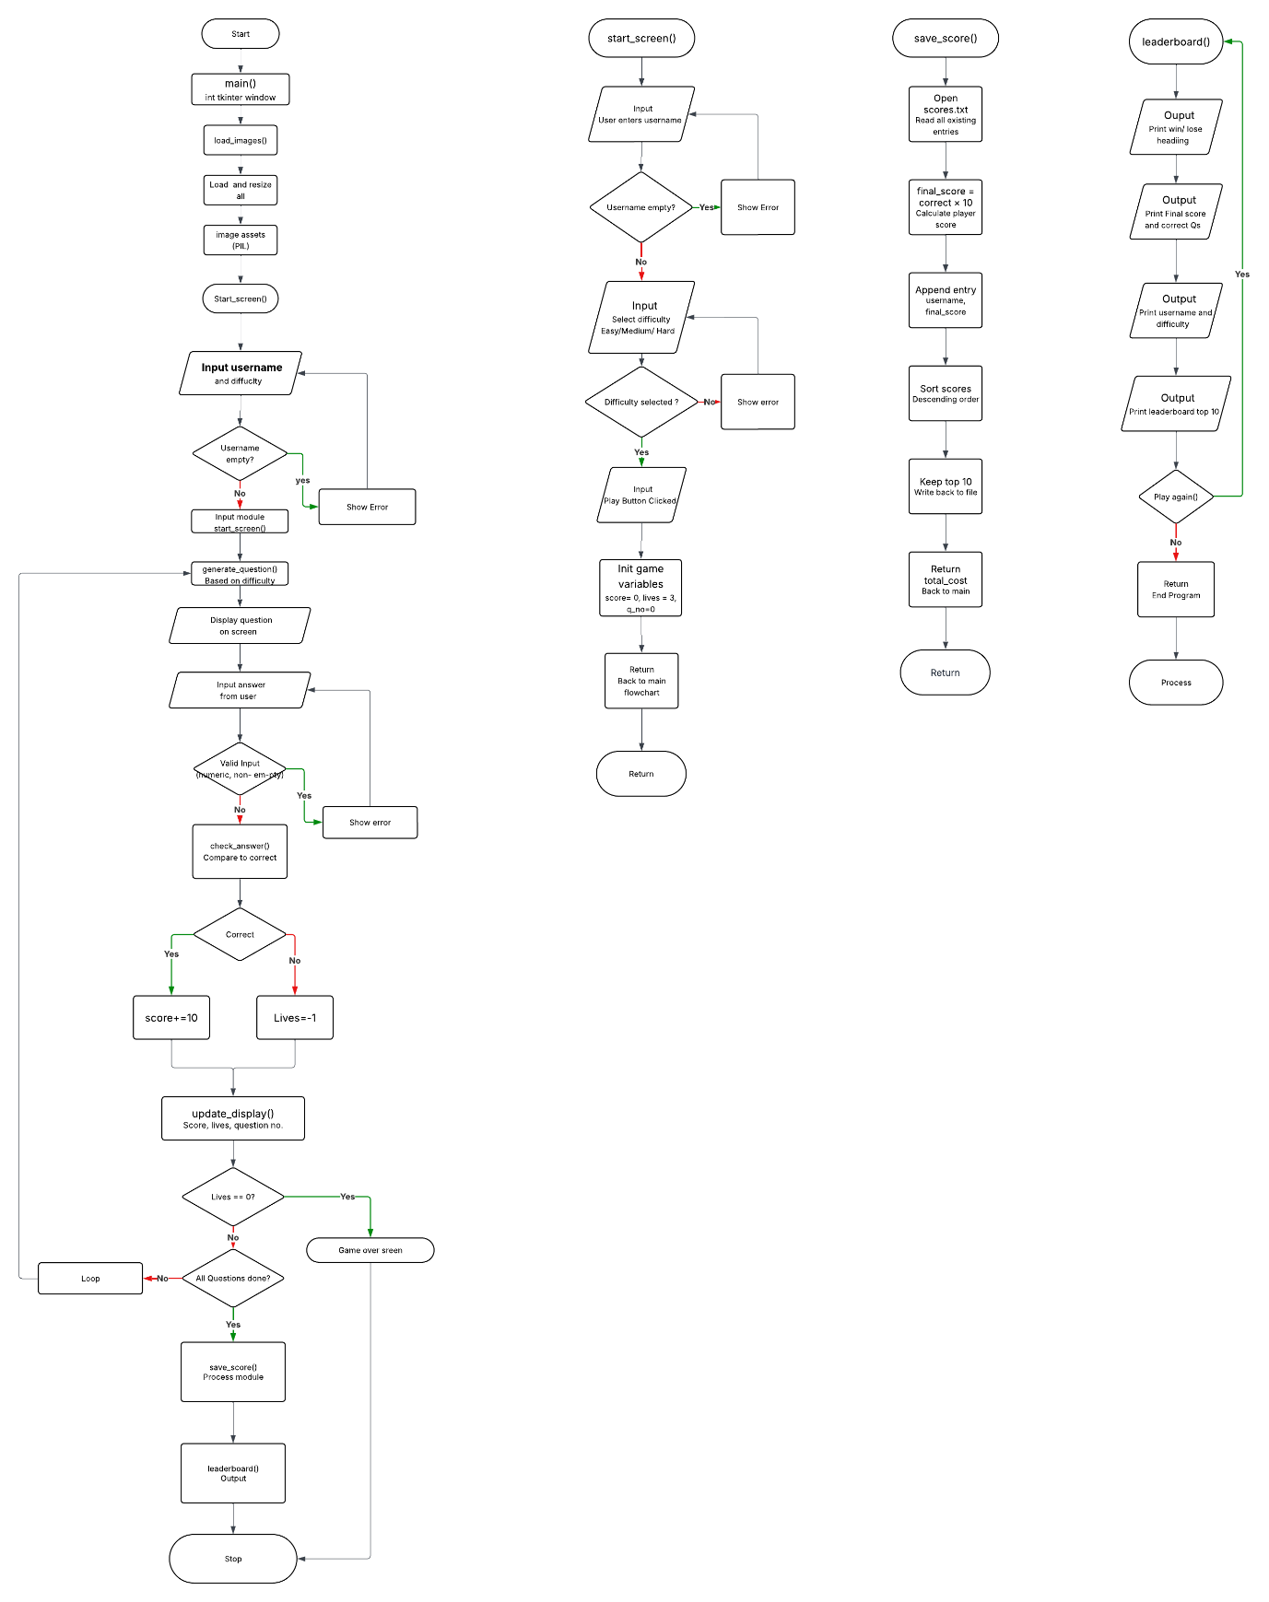wport_loc=-3375%2C-1381%2C11744%2C4881%2C0_0&invitationId=inv_7ab89630-89a6-437e-b025-977c203ff474
Tool 2: Flowchart (Lucid Chats): The second decomposition tool was chosen to be the flowchart as it shows the same exact logical flow of a program with the use of symbols, such as an oval for start and stop, a rectangle for processes, a parallelogram for input and output, and a diamond for decisions. The flowchart illustrates how the components in the program are linked and interact during the execution of the program, while the decomposition table breaks down the program into components. This allowed us to clearly define each decision point and validation loop without any code, which helped to minimize the risk of logic errors in the development process. This flowchart is also used directly as a reference when coding each function as the flow of steps is already mapped out visually.
Collaboration Tools:
- Perform some research on collaboration tools e.g. Google Forms, Padlet, Figma, Microsoft Teams, Microsoft Tasks, Microsoft Todo, Fleep, Monday.com.

Padlet: a collaborative online board for posting notes, images and links. It can also be used to gather informal feedback and preferences about the design from end users in a flexible freeform format.
Google forms: its document collaboration tool that allows many users to see, edit and comment on a shared document. Useful for sharing written documentation and receiving annotated, contextualised written feedback from peers.
Microsoft Word research: Microsoft Word is a word processing program that enables live editing of documents when shared on OneDrive. Users can insert comments on sections of text and make suggestions using the Track Changes feature. It's quite common in schools and can be used without any extra software or accounts other than a basic Microsoft logon.
- State which collaboration tool(s) you have chosen and justify your choice:
Tool 1: Google Forms: Google Forms was selected as the main feedback tool since it would enable structured questions to be shared with end users (classmates with the target user audience of high school students) and automatically put the responses into a spreadsheet. This made it easy to look at the patterns of feedback given, such as: Is a specific level too difficult or too easy for users; is the colour scheme readable for users. No sign-up is needed for respondents to use the tool, and it can be shared via a simple URL.
Tool 2: Microsoft Word (shared document): Microsoft Word was the second collaborator used to share the document file with peers on OneDrive or via email for comments and tracked changes to the document. Comments were available that enabled reviewers to markup specific parts of the document, such as indicating a wording of an error message that was confusing or adding a clearer description on a button. The tracked changes feature allowed for easy identification of the feedback provided and the implementation of the changes. All peers had access to Microsoft Word on all school computers and could add comments to it without creating any new accounts or software.

Version Control:

- Perform research on Version Control Tools e.g. Github etc:

Git - version control system is the most popular version control system in the world. It is free, open source and runs locally on your computer. Git records what you change in your code by "commits": snapshots of your project at a certain moment in time.
GitHub - a cloud-based platform that is based on Git. It enables you to store your Git repositories online, so you can easily backup your work, access it from anywhere and share it with others. There are also other features on GitHub, such as the commit history, branches, and the ability to roll back to any previous version of code.
GitHub - GitLab is an online source control/version control system, except that it can be hosted in-house on a company's own servers, which is why it can be used by businesses. It comes with integrated project and testing pipeline management tools.
- Version Control Tools chosen and justification for choice:
https://github.com/23797-hash/3-PAD-Flow-computing-Project#3-pad-flow-computing-project
(Add your URL to your GitHub link here – Test this in incognito mode and get your teacher to check that it works)
Trialling and Testing:

Note: You must select four components to trial, these can be used in the below trialling template, you can use other templates to trial your components, but you must trial a minimum of four. Refer to the implications such as usability, functionality, aesthetics as you complete your trialling:

Component 1: fonts
Trialling 1st Iteration: | Font: Courier  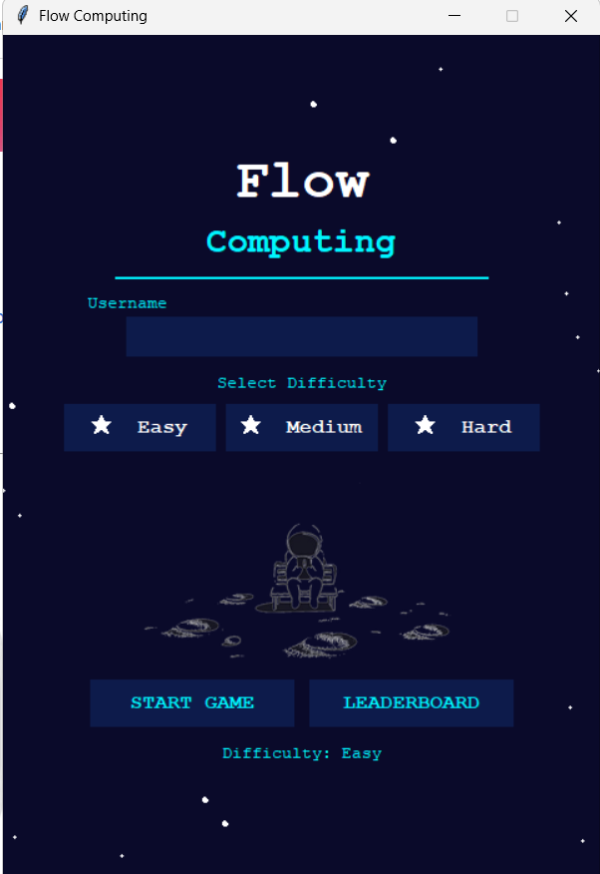  Font: Bahnschrift  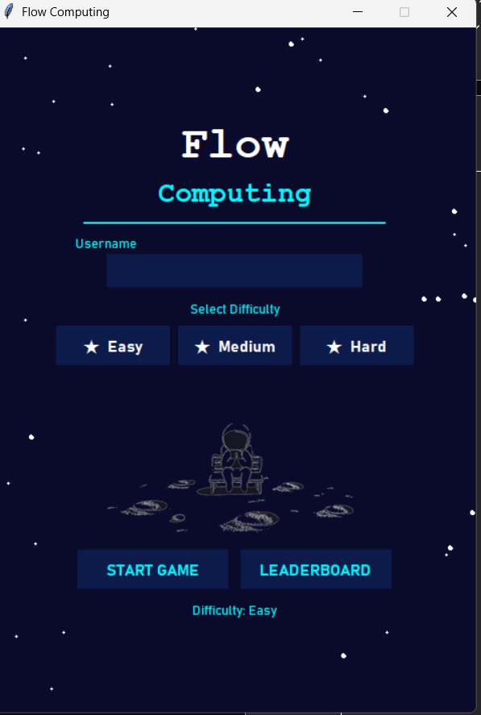  Font: Montserrat  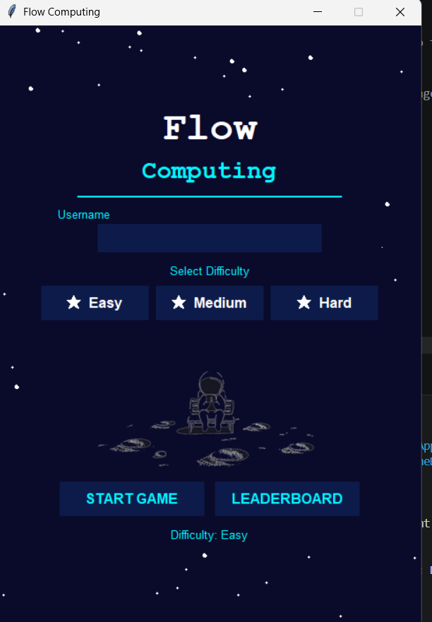  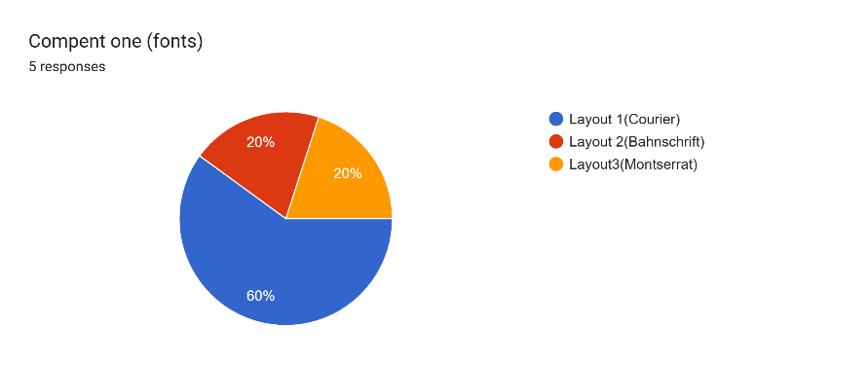
Evaluation of Response: | Three font choices were tested: Courier, Bahnschrift and Montserrat. All three were displayed on a Google Form to the classmates through screen shots. Most responders liked Courier, because it seemed to correspond to the space and retro tech theme of the program and because it appeared like a computer game interface. Bahnschrift and Montserrat were said to be too modern and a normal everyday application instead of a game, which did not fit the theme of the game.
Trialling 2nd Iteration |   Option 1 = 12px body text and 26px titles.  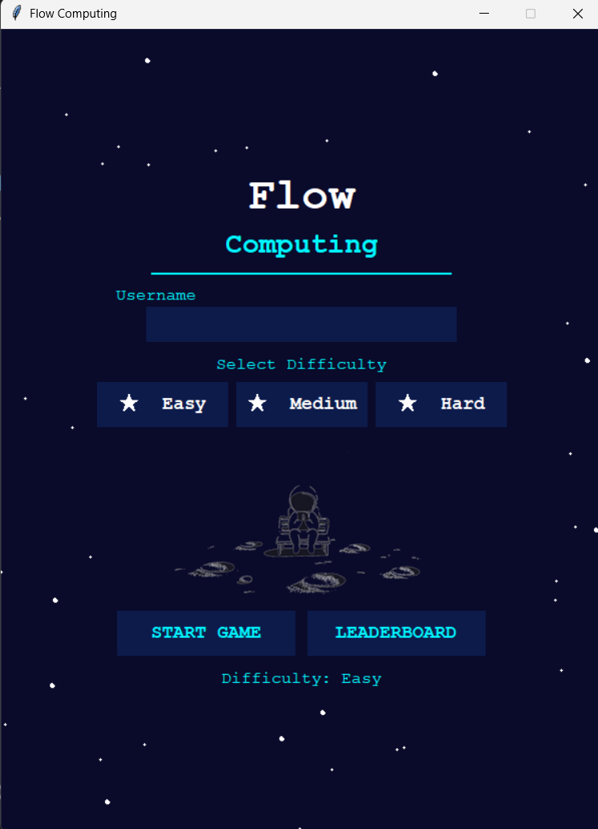  Option 2= 14px body text and 30px titles  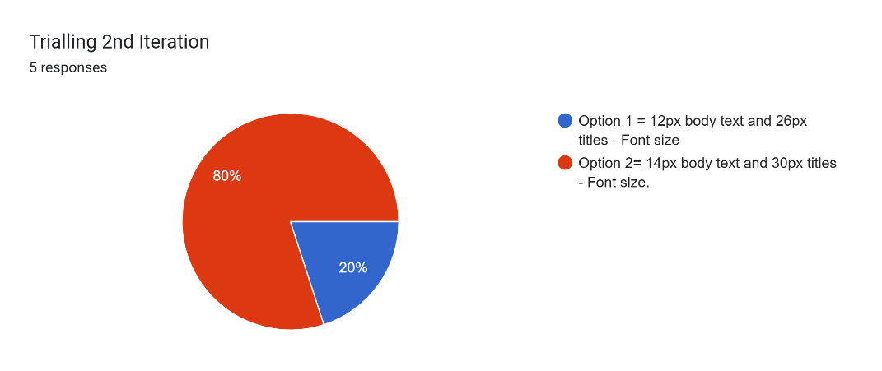  Feedback on component option:  Option 1: 12px body text and 26px titles were displayed to classmates, as well as Option 2: 14px body text and 30px titles. The majority of the respondents indicated that option 2 was easier to read, but also had the problem of being too cramped in the set window size of 480 x 680.
Modifications made base on 2nd iteration: | 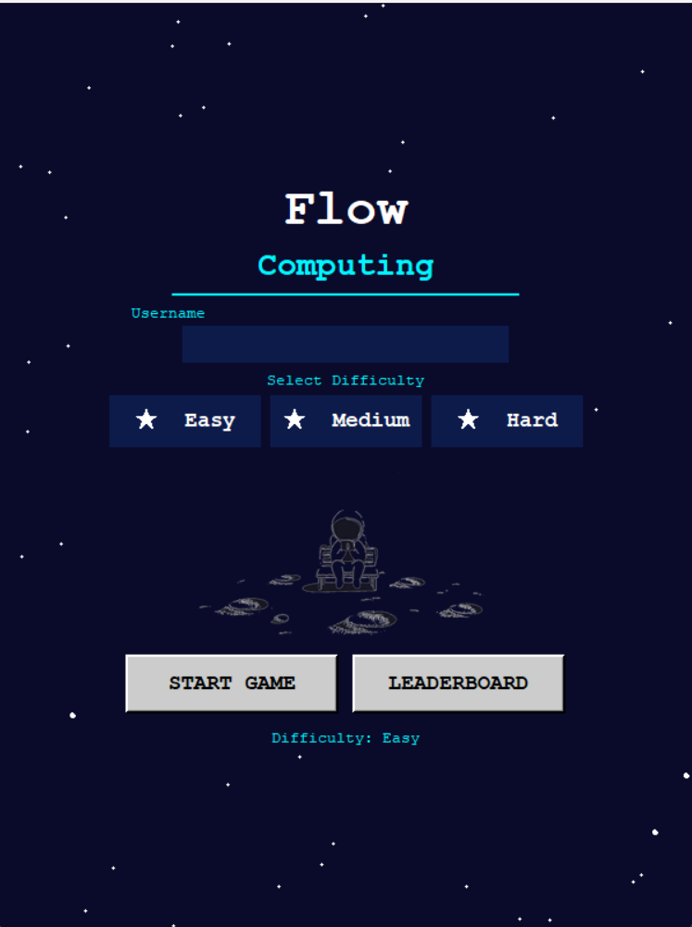  It was decided to compromise: The title stayed 26px bold and the body text stayed 12px, but there was increased padding around the elements to make it easier to read without preventing the layout from working.
Which did I choose and why? | I selected Courier at 12px body and 26px title as it was the most popular font with classmates and it worked best for theme of the program, space exploration. The monospace style of a typewriter gives the interface a futuristic and technical look, which Bahnschrift and Montserrat could not have done. The smaller font size was not changed as the larger font would have caused layout problems within the fixed window, and the additional padding solved the readability problem that was noted in the second iteration.

Component 2: Window Size
Trialling 1st Iteration: | Window Size480×680 pixels  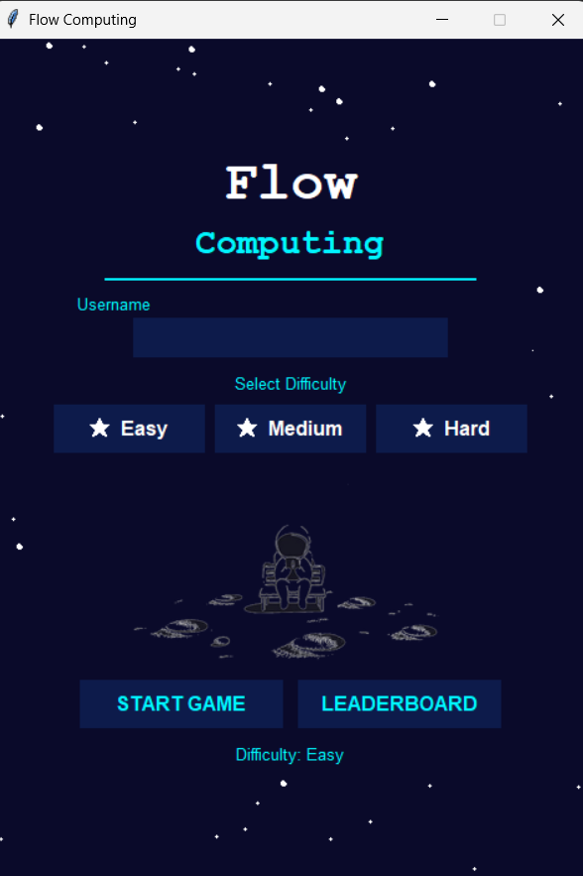|  Window size; 600×800 pixels  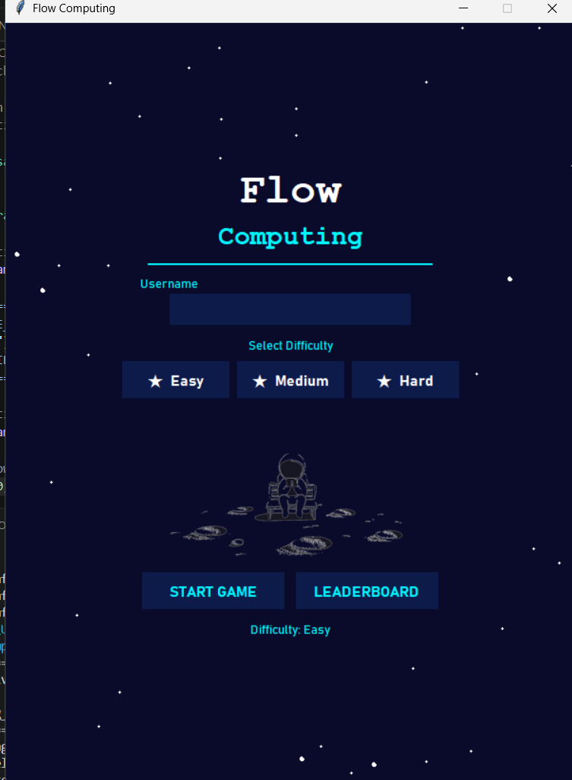  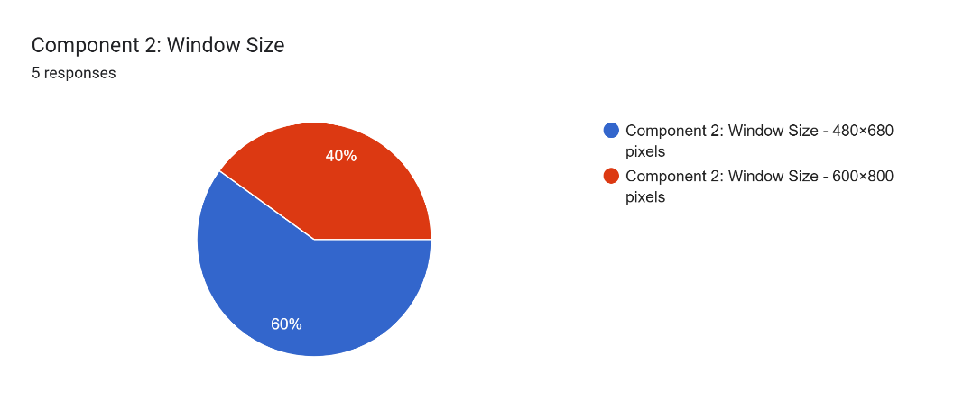
Evaluation of Response: | The two window sizes that were tested were: 480×680 pixels and 600×800 pixels. A Google Form was created and shared with classmates with screenshots of both. Most of the responders chose the 480×680 size due to the fact that all of their School's laptops were able to display the entire image without cutting off parts. The 600×800 resolution was called too big and that there was too much empty space, especially on smaller screens in the school.
Trialling 2nd Iteration | 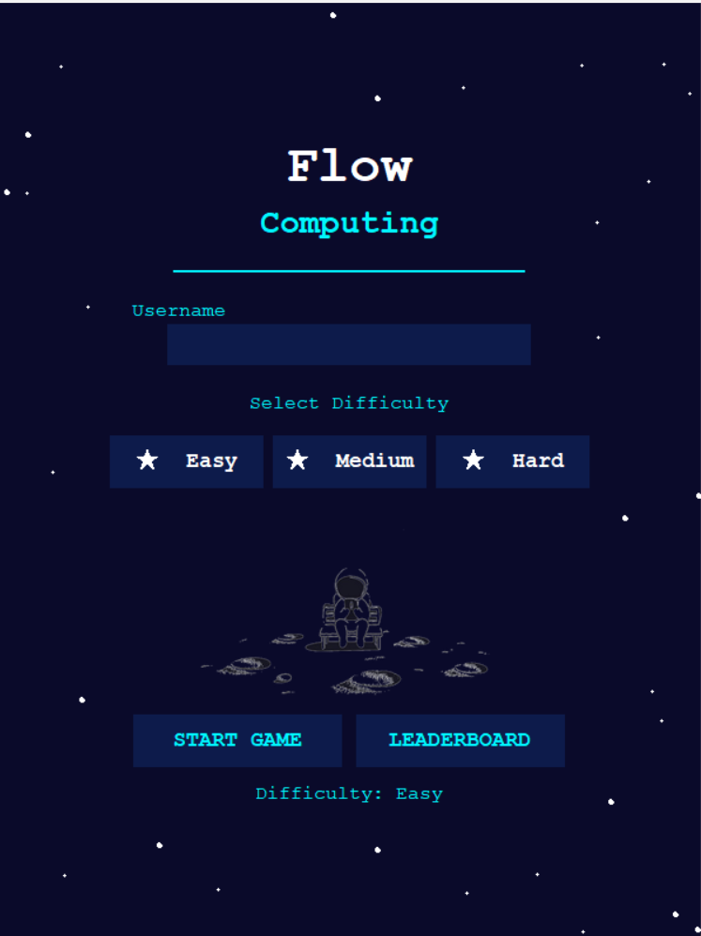  Option A: spread out (more padding/gaps)  Option B: compact (less padding, tighter):  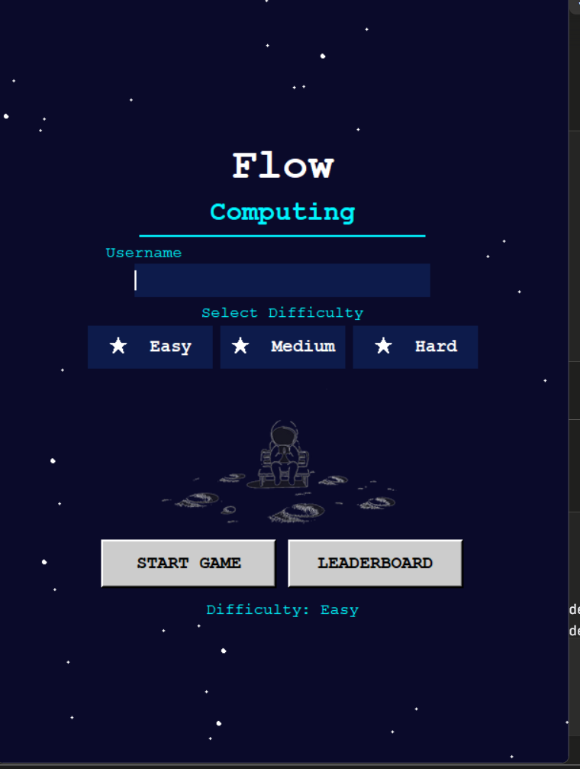  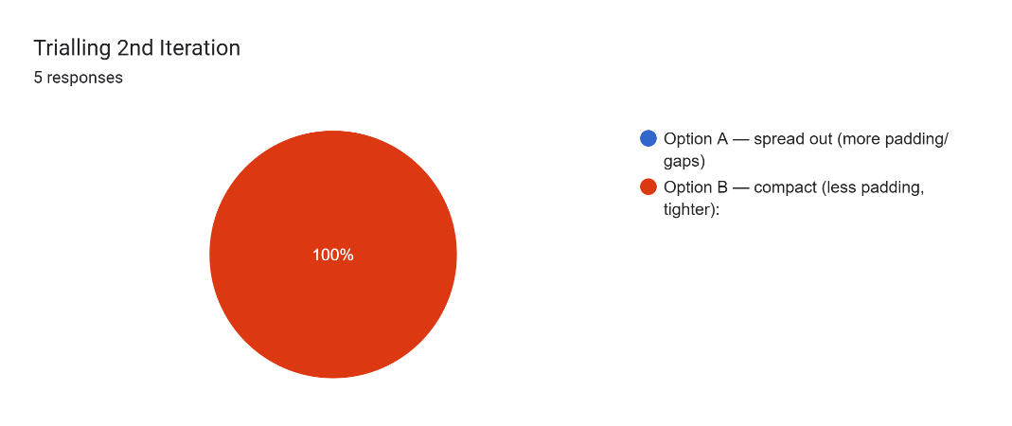  Feedback on component option:  Two different layouts were tested: Option A had large gaps of padding between the elements in the 480×680 window, and Option B had the elements compact and centred. Students in the class liked Option B better, because it made the screen complete and full as all the elements had a clear purpose.
Modifications made base on 2nd iteration: |   The arrangement of the building was compacted to the centre, therefore the final form was achieved. Across the start screen, padding was decreased to make elements closer together, and make better use of the space available within the pre-sized window.
Which did I choose and why? | The compact layout was chosen as it was confirmed as looking the most polished and 480×680 was chosen because it was compatible with all school laptops. Fixed window size also guarantees that the layout will always look just as intended, even with different screen resolutions from the user.

Component 3: Button Style / Layout
Trialling 1st Iteration: | 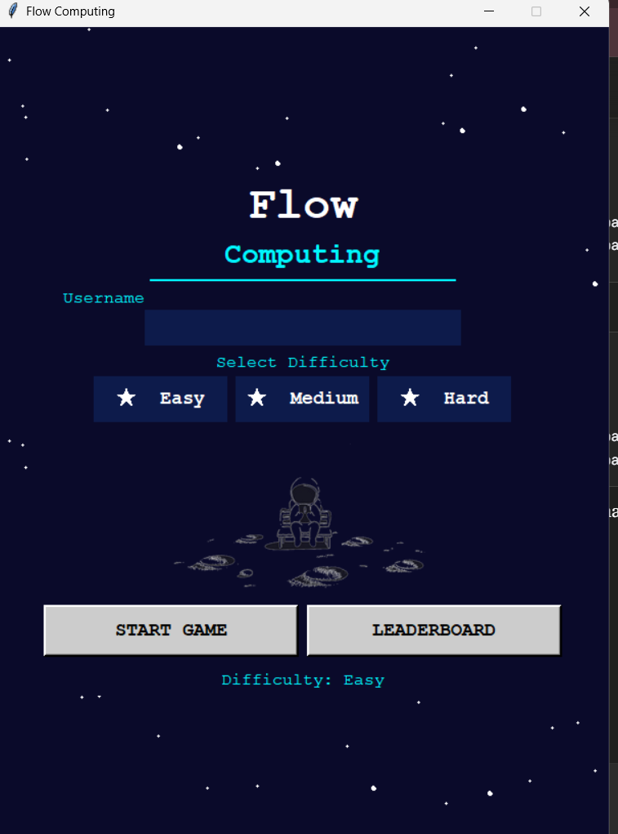  Option 1: Button Style / Layout  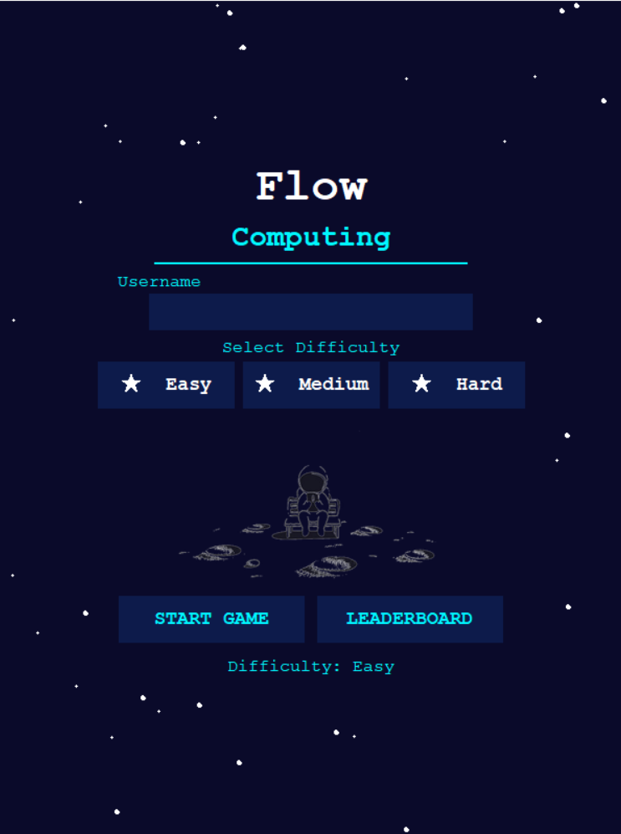  Option 2: Button Style / Layout  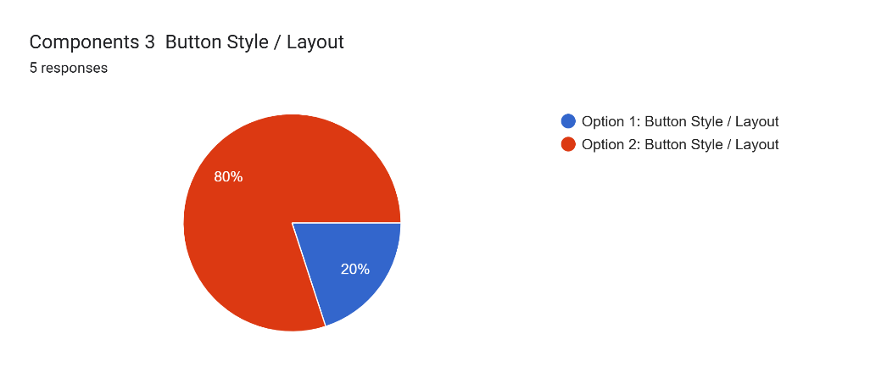
Evaluation of Response: | Two variations of the button format were tested: Option 1 featured flat rectangular buttons with a cyan outline, and a cyan change on hover; Option 2 featured 3D-style buttons raised up off the page, and grey with no change on hover. Screenshots were shared with classmates via a Google Form. Most of the respondents liked option 1 as buttons were interactive, modern with the hover effect and style was cyber. The use of option 2 was reported as "old fashioned" and "out of the system" with the rest of the design.
Trialling 2nd Iteration |  Option 1: Button layout (side by side)    Option2: Button layout (stacked)  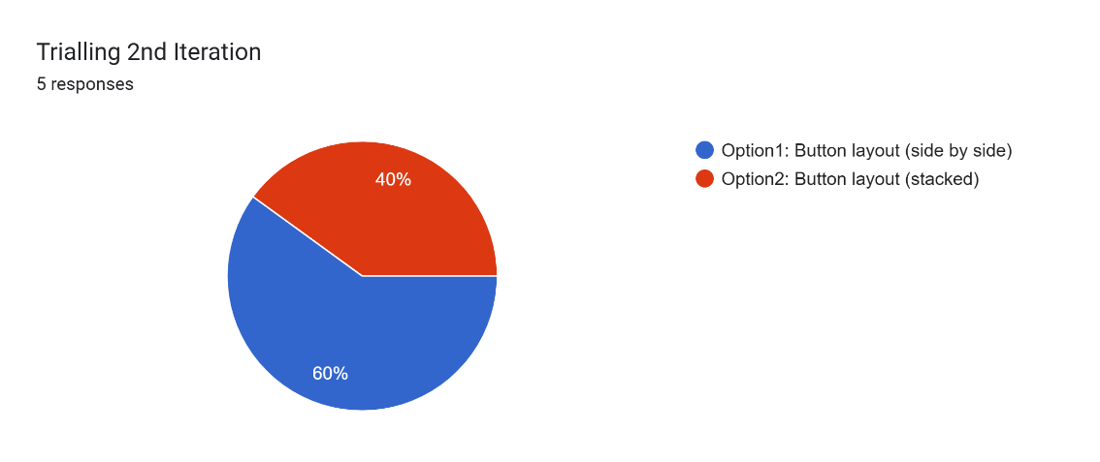  Feedback on component option:  For the start screen, two different layouts for the buttons were tested: Option 1: START GAME and LEADERBOARD were displayed side by side on one line, and Option 2: START GAME and LEADERBOARD were placed in a row vertically. With the exception that the majority of the classmates preferred Option 1, which had less vertical space usage and appeared more balanced in terms of screen space.
Modifications made base on 2nd iteration: |   The side by side layout was kept as the final design. The width of the button was made 18 characters then changed to 14 characters wide in order to fit the two buttons in one row.
Which did I choose and why? | Dropped the flat cyan border buttons in a side by side layout as the winning buttons in both iterations of the class voted. The hover effect provides interactivity, making the program feel responsive and engaging, whilst the side by side layout ensures a limited start screen is visually balanced within the fixed window size.

Component 4: Leaderboard Display Style
Trialling 1st Iteration: | Option A (Listbox)  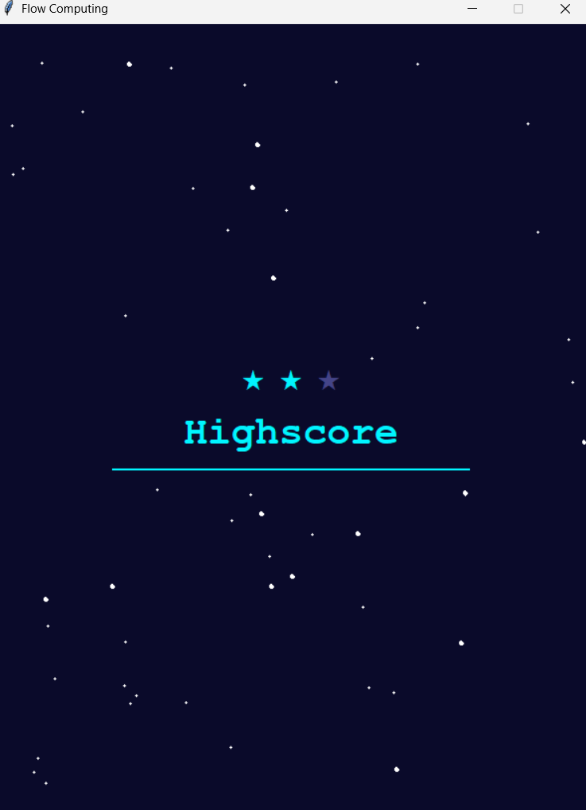  OptionB:  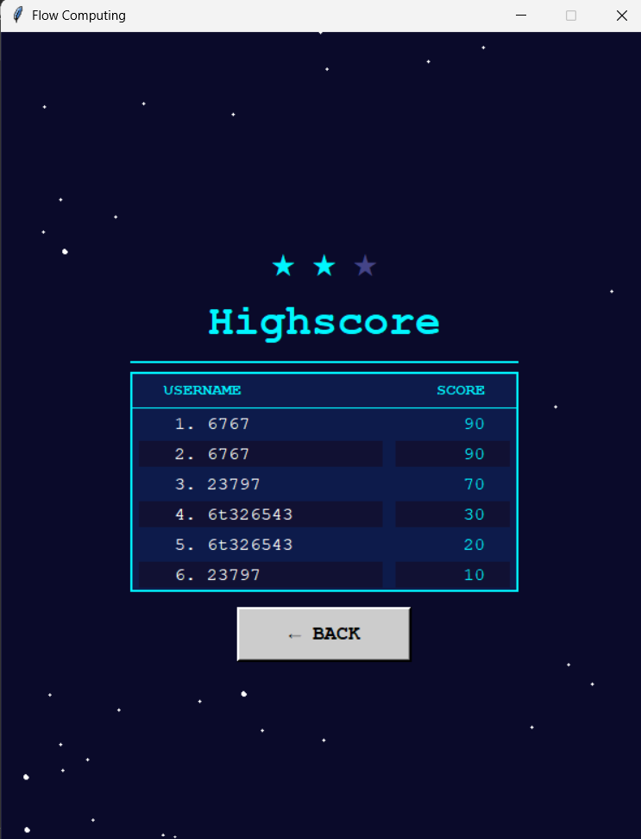  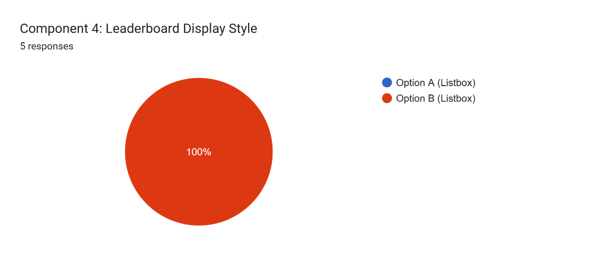
Evaluation of Response: | Two styles of a leaderboard were tested: style A was a Listbox with simple text rows like "1. Janidu 100", with row colours alternating and a cyan border; style B was a row and column headered styled grid table, with a cyan border, alternating row colours, and flat text rows like "1. Janidu 100". A Google Form was used to share screenshots with other classmates. Most responders chose Option B as the columns clearly distinguished the username from the score, allowing them to read it more easily, and alternating row colours made it easier for their eyes to follow each score. The Listbox was described as hard to read and boring, especially when usernames were different lengths causing the scores to misalign.
Trialling 2nd Iteration |   Option A (alternating dark blues)  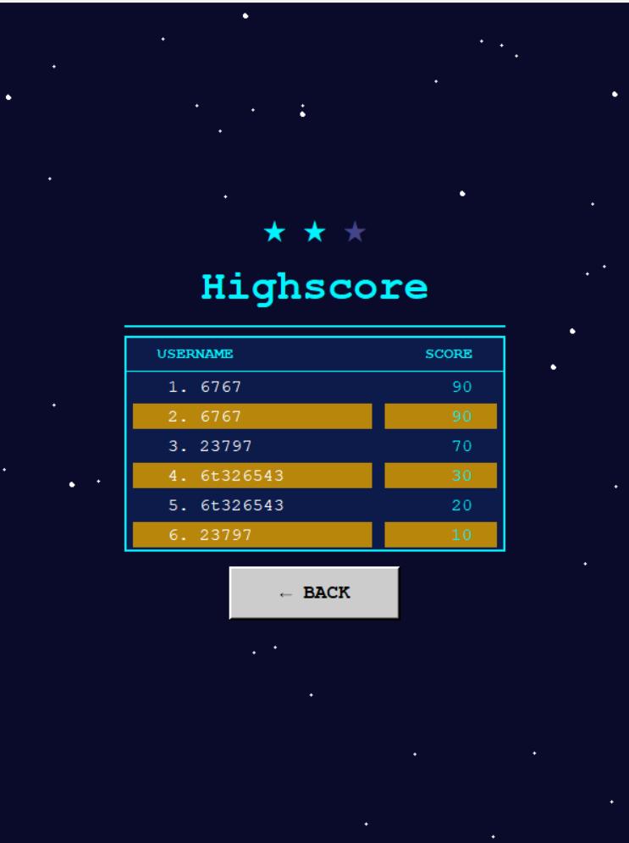 Option B (gold alternating rows).  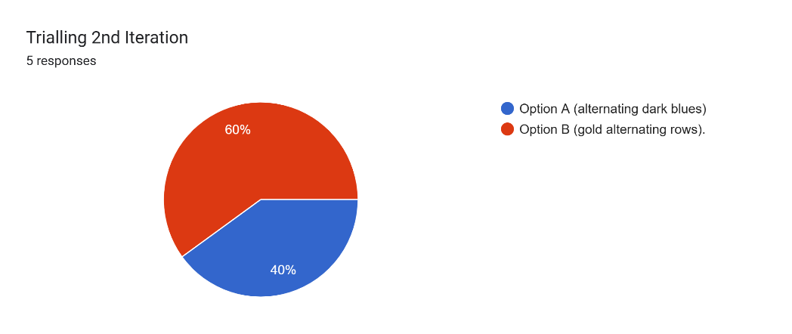  Feedback on component option:  Two different schematics were used for the leaderboard rows: Option A was made of alternating dark blue (#0D1B4B) and navy (#111133) and Option B was made of alternating dark blue and gold (#B8860B) for contrast. Option A was the preferred choice by classmates as the alternating blues were subtle and complied with the overall tone of the dark space. The cyan colour scheme was found to be distracting and contrasting with the gold in Option B.
Modifications made based on 2nd iteration: |   The subtle alternating blue rows (Option A) were kept as the final design. Based on feedback, the gold colour scheme was rejected.
Which did I choose and why? | Because it was much more readable and was voted on by a lot more people than the Listbox in the first round, I selected the styled grid table with alternating dark blue rows and a cyan border. After the second run, the subtle alternating blues were determined to be less distracting and more in keeping with the aesthetic theme of the program for the rest of the space than the gold option.

Testing Plan (Example)

Input | Data Type | Example Input | Expected Output | Actual Output
answer_entry | Valid Data | 3 | Answer accepted, score increased by 10, next question comes up or if | 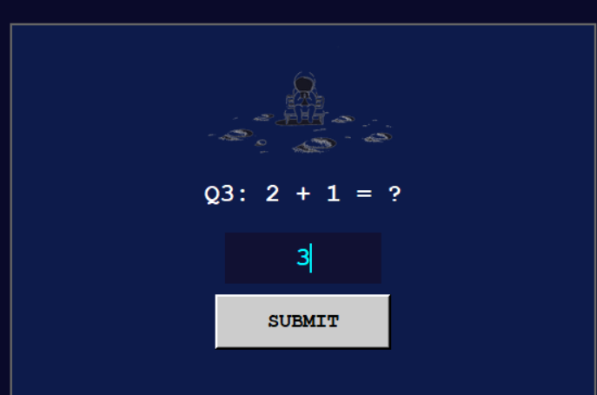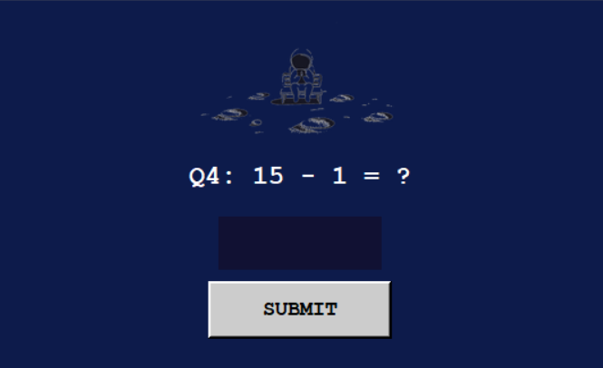
answer_entry | Valid Data | -5 | Negative marks are possible | 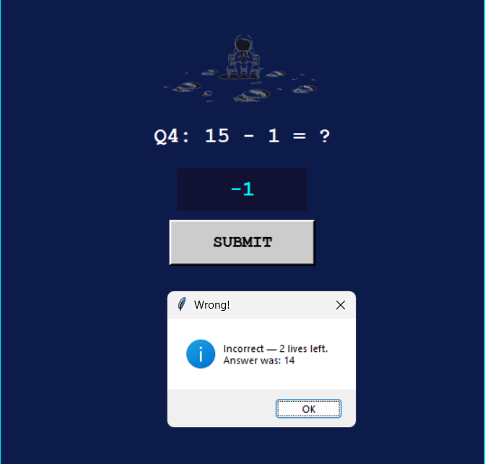
answer_entry | Invalid Data | abc | Error message pops up: “Numbers only – no letters or special character | 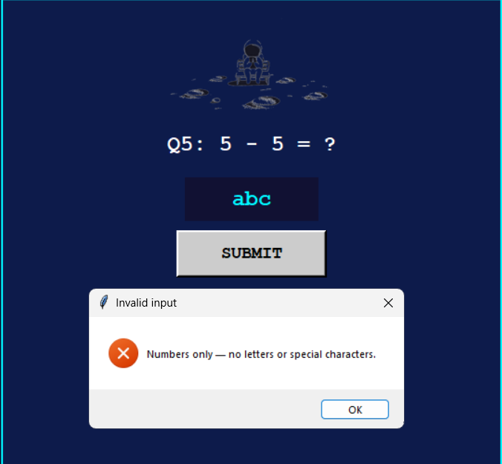
answer_entry | Invalid Data | 5#! | Error message pops up: “Numbers only – no letters or special character | 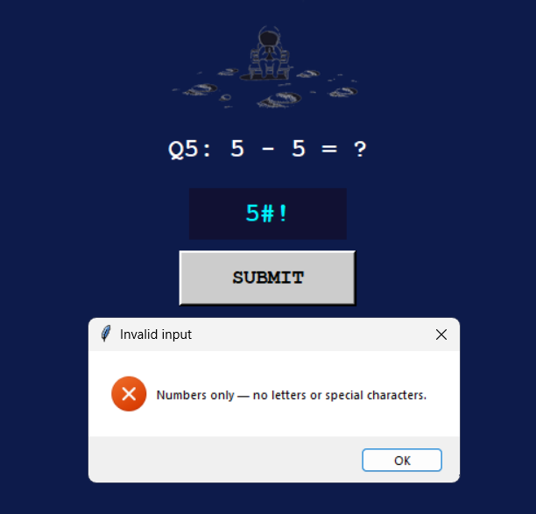
answer_entry | Invalid data | (empty) | Warning message: “Please enter an answer” | 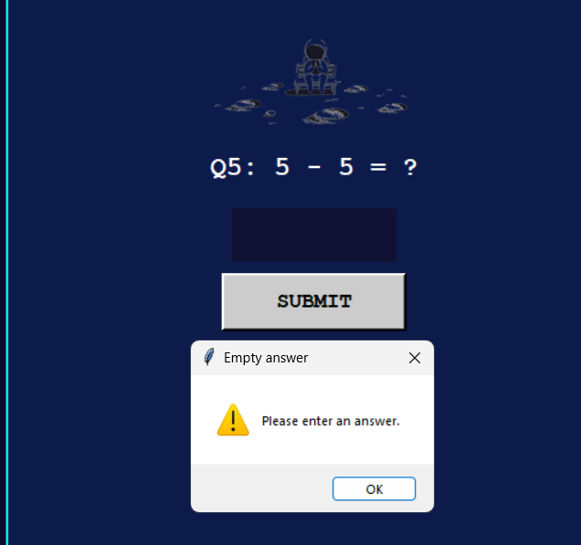
answer_entry | Boundary Data | Q2 correct answer | First question accepted, score goes from 0 to 10 | 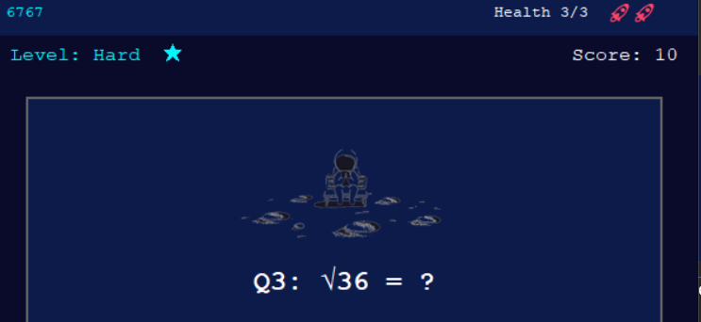
answer_entry | Boundary Data | Q11 correct answer | Win screen displayed after final question answered corrextly | 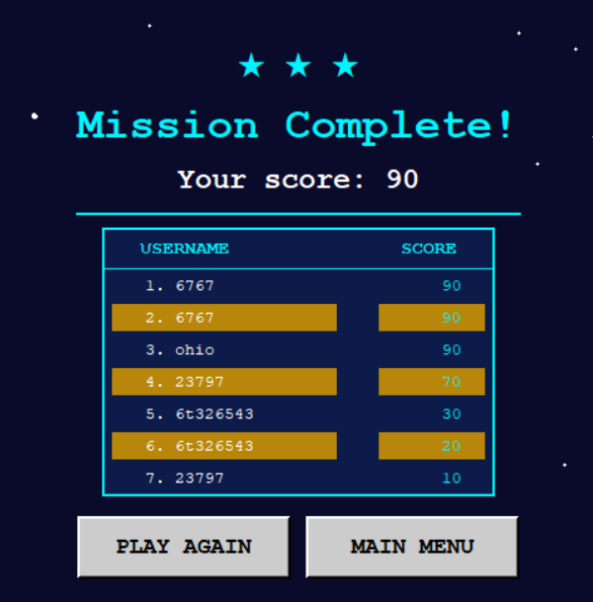
answer_entry | Boundary  Data | Wrong answer with 1 life left. | Game over screen displayed, lives reach 0 | 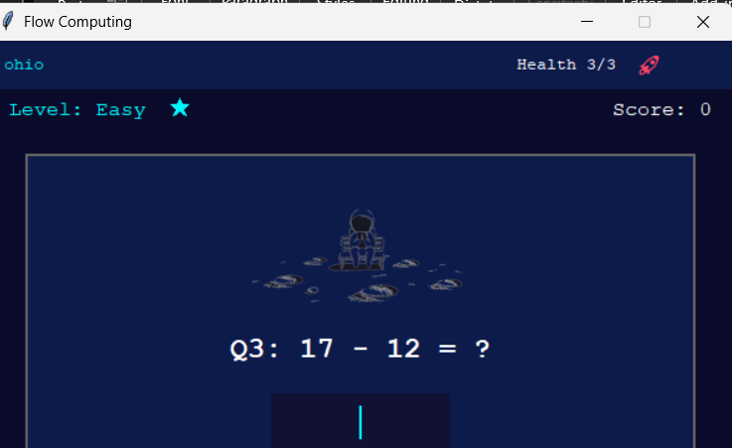
username_entry | Valid | Janidu | Username accepted, game starts successfully | 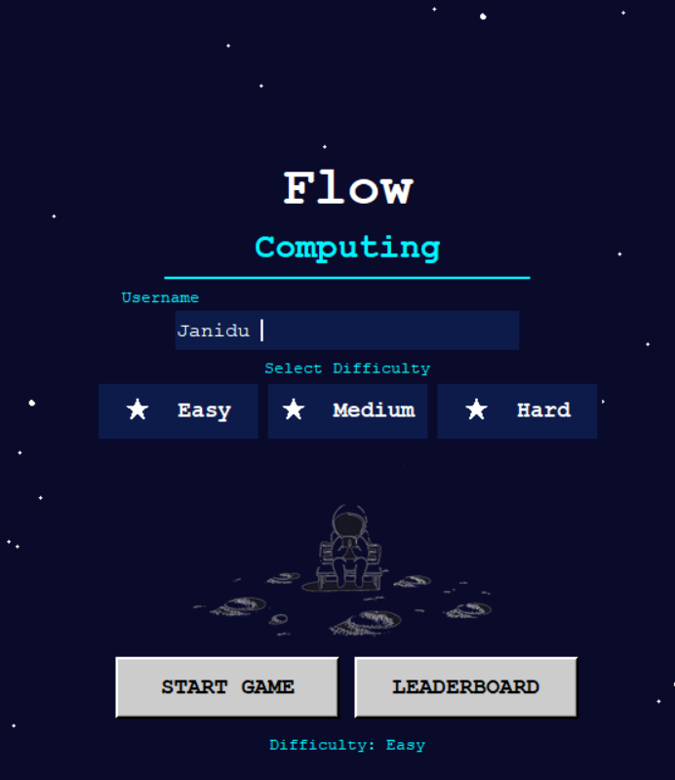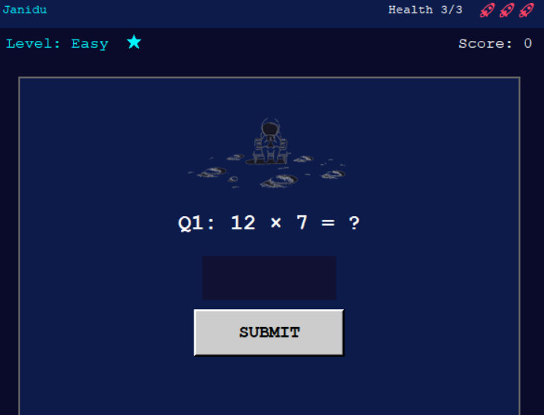
username_entry | Invalid | (empty) | Warning message: "Please enter a username to start" | 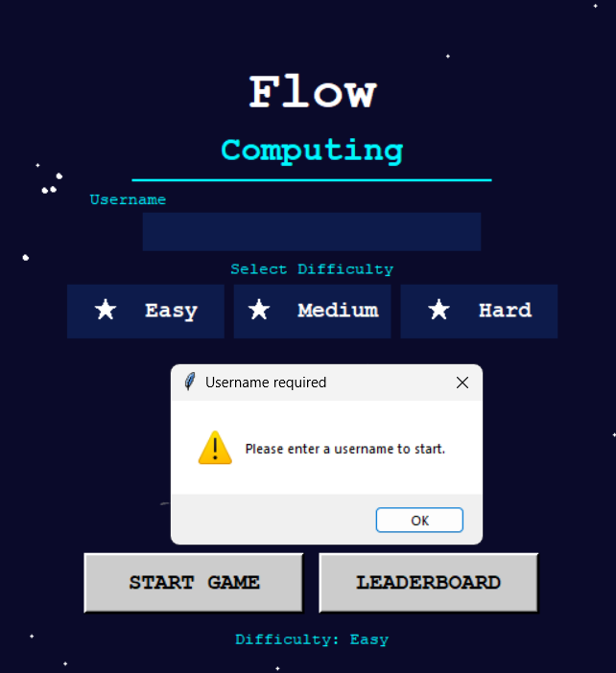

Note: For Merit and Excellence, boundary testing should include values at, below or above the boundary.

Final:
Loading screen:
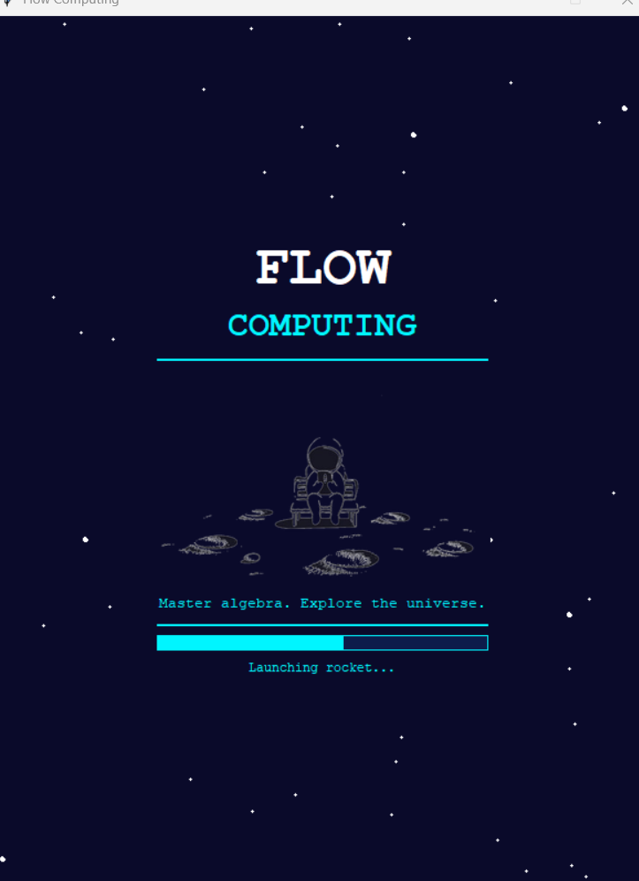
Start screen:

Game screen:

Leaderboard/ End screen:
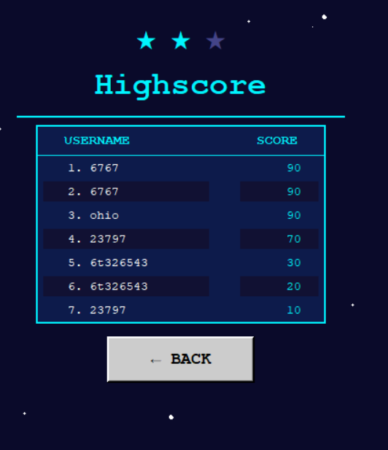

Evaluation:

In the space below add critical reflection/evaluation of project management tools:

The Gantt chart was useful to set a clear time line for the project and it helped to allocate an adequate amount of time for every stage of the project (planning, GUI development, coding functions, testing, documentation). During the trialling phase the leaderboard component took longer than expected, the Gantt chart made this apparent early enough to make adjustments to the schedule and not be late on the final deadline. In fact, in student projects it is very common to underestimate how much time the testing phase takesand it would have been easy to, without the Gantt chart.
The Trello board integrated with the Gantt chart helped in tracking the status of tasks at the level of each task within the phase. Cards were created for each function, GUI component and documentation section and as work progressed were transferred from column To Do to column In Progress, then Testing, and finally Done. The function card validate_input was changed from Done to Testing because a classmate found that it did not properly reject decimal numbers during the trialling. This made sure that the bug was not overlooked and was recorded and fixed before it was turned in. The Trello board's visual nature also allowed users to easily view at a glance which parts of the project had been finished and which were still underway, keeping the project organized and helping to eliminate stress during development.
The two instruments became a part of an Agile workflow that enabled the development and refinement of individual components independently, based on the feedback from the trialling, while the Gantt chart maintained the overall timeframe. If I would do this project again, I would make the phases that are in the Gantt chart even smaller so that I could give myself more information about what I was doing at each phase of development.
Reflect on the evaluation of trialling, testing and feedback e.g. Did the Technological Process help you with your project?

(Add answer here)

List Five Relevant Implications and Evaluate your project related to these (Three of these must include functionality, usability and aesthetics) you cannot choose Health and Safety:

(Add answer here)

